**Total sales per product.**

**db.sales.aggregate([{$group:{_id: ”$product”,totalSales:{$sum:{multiply:[“price”,”quantity ”]}}}}])**

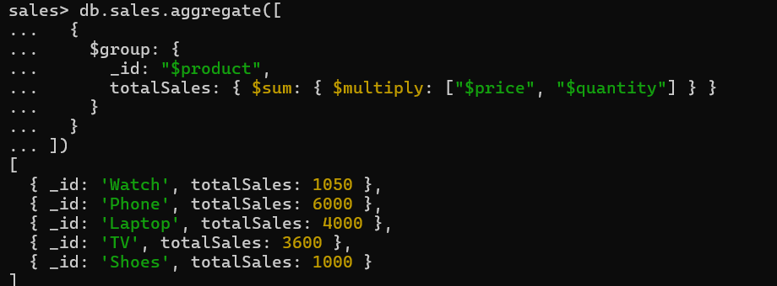

**Total revenue per product**

**--- this do sum of all products**

**db.sales.aggregate([{$group:{_id:"product",TotalSales:{$sum:{$multiply:["$price","$quantity"]}}}}])**

**[ { _id: 'product', TotalSales: 15650 } ]**

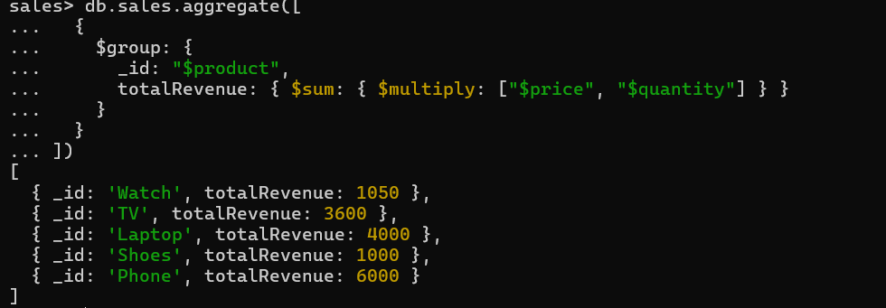

**Total revenue per category.**

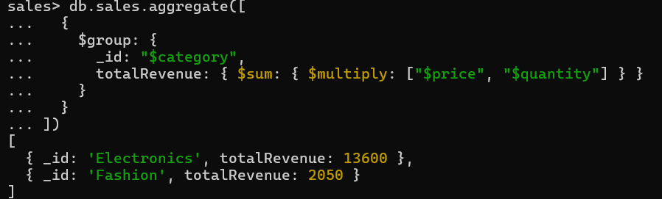

**Count of products per category.**

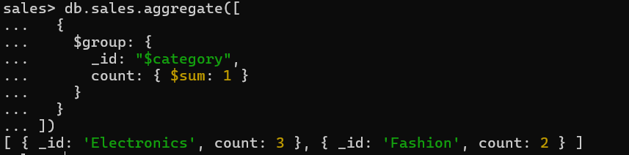

**Store-wise total sales.**

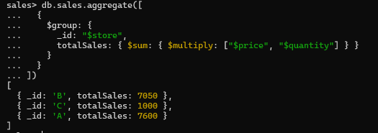

**Average price of products per category.**

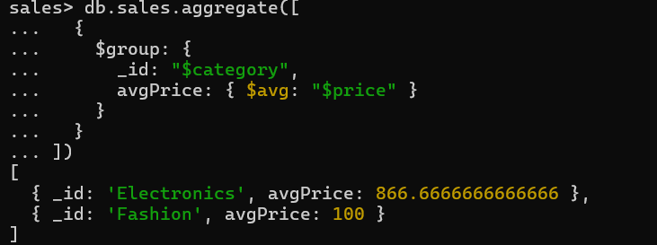

**Top-selling product.**

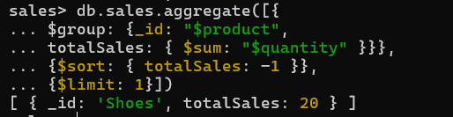

**Total sales for Electronics category.**

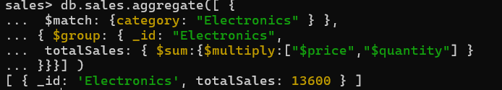

**Sales trend over time (day-wise total sales).**



**Highest revenue-generating product.**

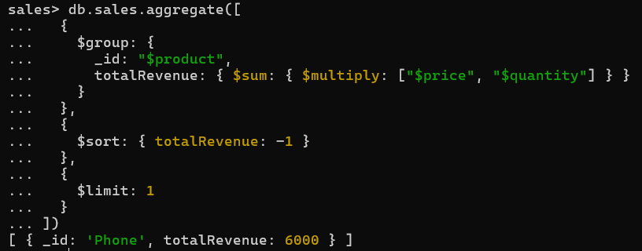

**Average revenue per sale.**

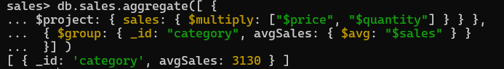

**Sales performance per store.**



**Products sold more than 5 times.**

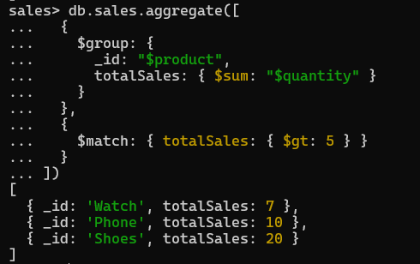

**Least sold product.**

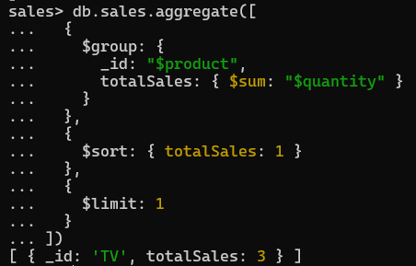

**Monthly sales summary.**

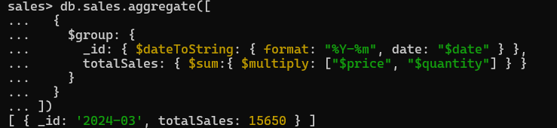

**Number of unique products sold.**

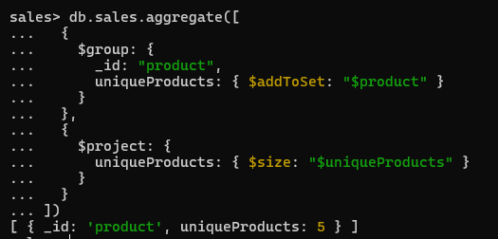

**Maximum and minimum priced product**

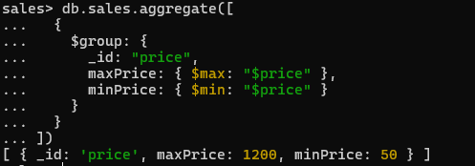

**Total revenue per product in descending order.**

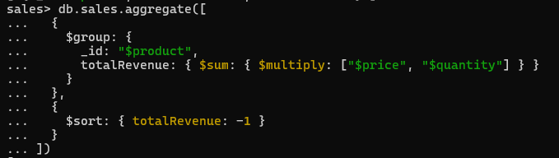

**Revenue generated per store per category.**

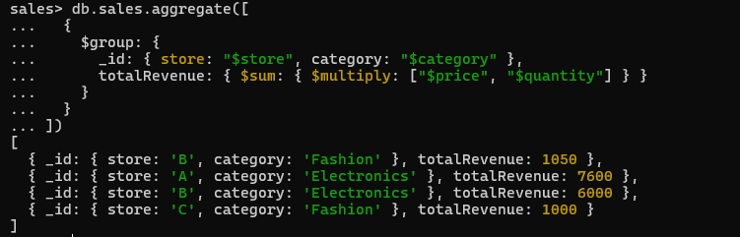

**Products contributing more than 50% revenue.**

